**ЗАЯВКА**

**за участие в Конференция на младите научни работници – 2018 г.**

**09 юни 2018 г.**

**Име, презиме, фамилия:** .................................................................................................................

**Академична длъжност и научна степен:** ...............................................................................

**Катедра:** ..................................................................................................................................

**Адрес за кореспонденция:** ...............................................................................................................

**Телефон:** .............................................................................................................……………………

**e-mail:** ..................................................................................................................................................

**Тема на доклада:** .........................................................................................................................................................................................................................................................................................................................................................................................................................................................................................................................................................................................................................................................................................................................................................................................................................................................

**Необходими технически средства за презентация:** .........................................................................

**Резюме на доклада**:

......................................................................................................................................................................................................................................................................................................................................................................................................................................................................................................................................................................................................................................................................................................................................................................................................................................................................................................................................................................................................................................................................................................................................................................................................................................................................................................................................................................................................................................................................................................................................................................................................................................................................................................................................................................................................................................................................................................................................................................................................................................................................................................................................................................................................................................................................................................................................................................................................

**Ключови думи:**

............................................................................................................................................................................................................................................................................................................................…………………………………………………………………………............……………………………..……………………………………………………………...........…………………………………………..

**Дата:** ............................... **Подпис:** ...............................

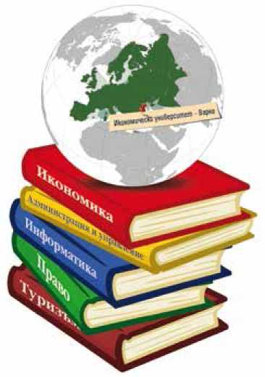

***Конференция на младите научни работници***

*се организира в рамките на Дейност 7 „Организиране на национални и международни научни форуми за разпространение на научната продукция на докторанти, постдокторанти и преподаватели“ на Проект* ***“Инвестиции в обучението на студенти, докторанти, постдокторанти и преподаватели – гарант за по-добро бъдеще“***