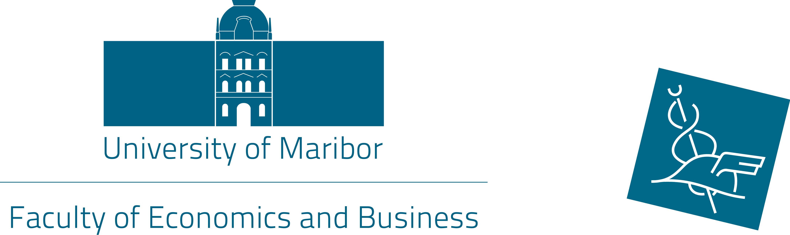

10th International week
17 – 20 May 2016

Dear precious colleagues,

It is a great pleasure to invite you to the »10th International week« hosted by the University of Maribor, Faculty of Economics and Business, in Maribor 17 - 20 May, 2016.

The purpose of the international week is to augment international collaboration between the partner institutions and companies. By the project of International week, we would like to increase the students' mobility, recognition of the organisations and our faculty as well as in the international area, to promote international studies and to approach »international« mentality to the students.

- Symposium of foreign partner institutions representatives (May 17th, 2016)

In order to strengthen international cooperation with the partner's institutions, we are organising »Symposium of foreign partner institutions«. For this purpose, the presentation of your institution will be performed to other participating guests as well to academic staff of our institution. Presentation of your institution (PPT) should last 10 - 15 min.

- Topics of the lectures, presentations and workshops (May 18 - 20th, 2016)

Part of the International week programme is based upon of different presentations, talk and discussions, round-tables and lectures given by the visiting lecturers or visiting guests from our partner universities connected with international effects, that are going to stimulate student's mobility. The topics of the presentation (lectures) should be connected to the economics and business area.

- Participants

The participants of the international week are lecturers of business and economics field from our partner universities. As well, the international week is open to non-academic staff. The students are both Slovene and international on undergraduate and postgraduate level.

The language of the International week is English.

- Social programme

You are warmly invited to join us in city tour of Maribor as well in tour in Winag wine cellar!

- Costs

The participants should cover their travel and accommodation costs through Erasmus+ mobility programme (TSM-Teaching Staff Mobility and Staf Mobility).

- Registration

The registration is open until 15th April 2016. Application form is also attached.

If you have any questions, do not hesitate to contact International Project Team!

We are looking forward to seeing you in Maribor, Slovenia!

Yours faithfully,

International Relations Office

