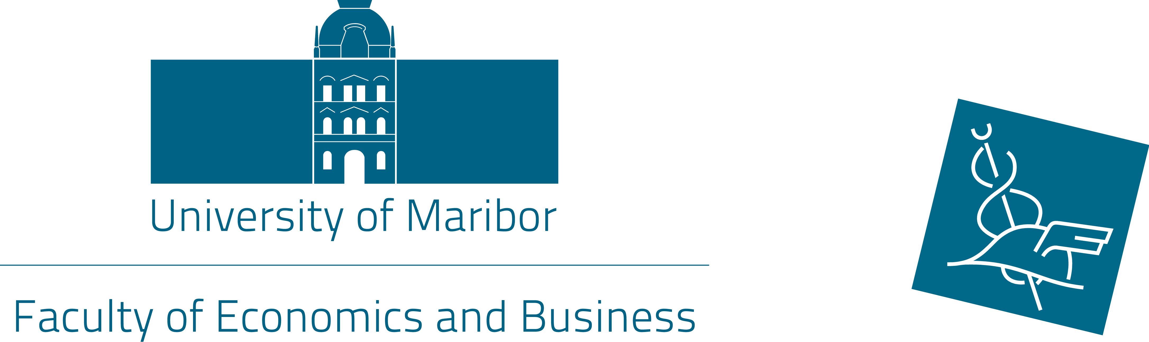
Application form

International week

organized by
Faculty of Economics and Business

17 – 20 May 2016

1. Personal data:
Full Name
(first name/family name)
Department
Area
Position
Contact details (e-mail address and
phone number)
Spoken language(s)
2. Home University:
Official Name
(in English)
Address

ERASMUS Code
Name & contact details of Erasmus Coordinator

3. Topic of the lecture (TSM) or presentation (ST ):
(Please name one or two topics which you would like to lecture during the International week):

Level of English:

4. Date of arrival and departure:

5. Accommodation information:
We have already pre-booked rooms for the participants at very reasonably price at the below mentioned hotels!  Please choose one option: | Please make the reservation of room (email) by yourself !
Hotel Bajt  Link: http://www.hotel-bajt.com/en/  39eur/night including breakfast for single room | YES NO
Hotel Tabor  Link: http://www.hoteltabor-maribor.si/en/  42,50/night including breakfast for single room  59,50/night including breakfast for double room | YES NO
Other:

Date:
Signature of Applicant

Date:
Signature and stamp of Erasmus Coordinator of Home University

Please return your application form by e-mail to
sanja.kocijan@uni-mb.si or polonca.mlakar@uni-mb.si or
by fax to + 386 2 22 90 217
until Friday, 15th April 2016!

