

INFO SHEET FOR INCOMING VISITORS

ACCOMODATION INFORMATION

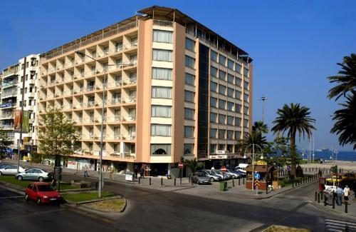
There are many hotels in Izmir however the nice and comfortable ones are quite expensive. We recommend you İzmir Palas Hotel which is located just at the city center on the Izmir Bay.
Address:

Ataturk Caddesi 35210 Izmir TURKEY
Tel: +90 232 465 0030
Fax: +90 232 422 68 70
http://izmirpalas.com.tr
info@izmirpalas.com.tr
Reservation: Please contact: Mrs. Melike Olcaytürk, melike.olcayturk@yasar.edu.tr
Prices
* The prices include breakfast and VAT
 | Single | Double | Triple
Sea View Rooms | 190 TL | 280 TL | 340
City View Rooms | 170 TL | 260 TL | 320

University Dormitory:
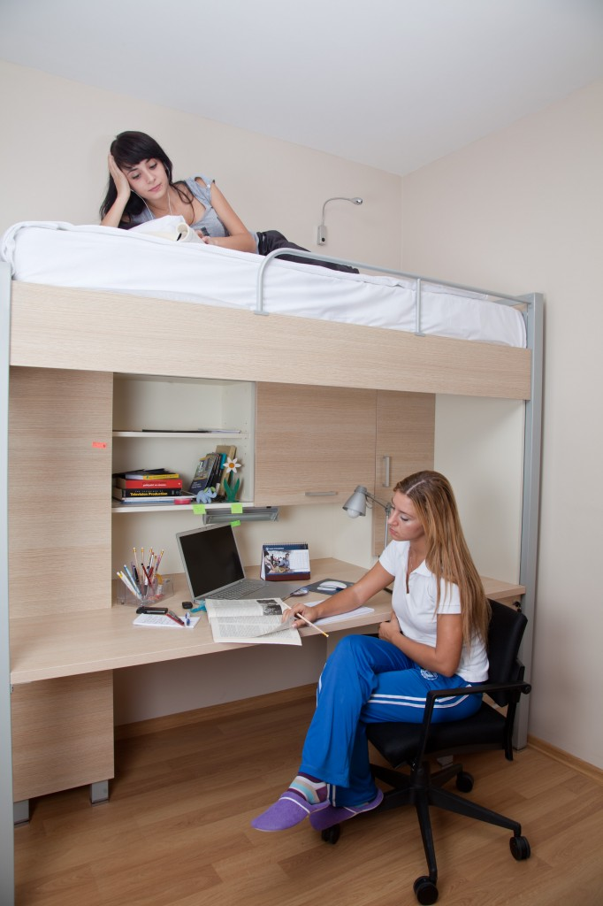
The dorm is usually full during the school time, however if there is available room, you can also stay at the university’s dormitory.
The dormitory is located just 5 minutes walk to the university. It is not in the city center.
Single Room Price: 65 TL per night ( including breakfast)
Double room Price: 55 TL x2 = 110 TL per night ( including breakfast)
Reservation: Please contact yurt@yasar.edu.tr

TRAVEL INFORMATION

From Adnan Menderes Airport to City Center
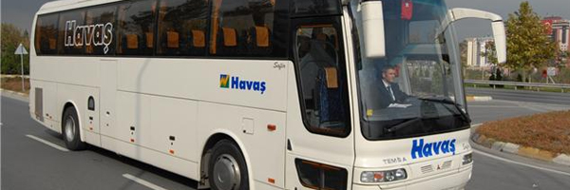

By HAVAS Shuttle (Private Bus Company)
You can take the HAVAS shuttle from Adnan Menderes Airport to the city center. It is located just at the exit door of the airport and every hour there is HAVAS shuttle to the city center. (http://www.havas.net/en/OurServices/BusServicesAndCarParkingFacilities/ServicePoints/Pages/Izmir.aspx )
It costs about 10 TL per person. You should get off HAVAS shuttle at Swiss Hotel Stop. Then you can take taxi from the Efes Stop to Izmir Palas Hotel or walk the way (only 10 minutes).

By Public Bus:

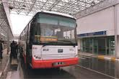
It takes longer to reach the city center, about 40 minutes. You must again get off at Swiss Hotel stop (last stop).
The bus departs from the airport on the each hour between 00:00-3:00 am and 05:00 am-23:00 pm. It is located just at the exit door of the airport. Price is about: 5 TL
For Izmir Palas Hotel: Take number 202 (Cumhuriyet Meydanı Direction)

By Taxi:
You can also take a taxi from the airport and it costs you about 15-20 Euros or 50 TL to come to your hotel from the airport.

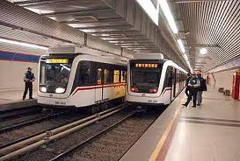
By Metro:
For Yasar University Campus: From the airport you can take metro. Get off at "Halkapınar" station to change route. Take the route to "Evka-3". Get off at “Bölge” stop where Yasar University is located.

From İzmir Palas Hotel to the University: Better to take taxi, but please indicate you want to go to Yasar University Bornova Campus. It costs about 40 TL

EATING OUTSIDE

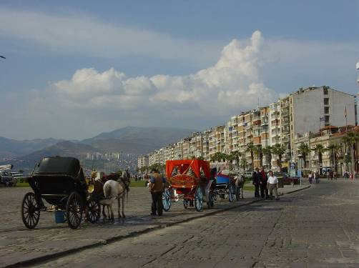
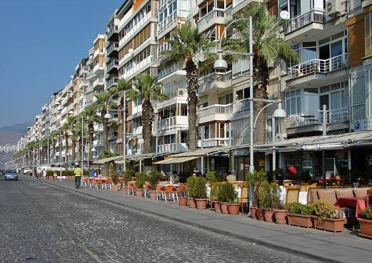
There are many restaurants, cafeterias and bars on Kordon Bay that you can enjoy. Your hotel is just located on this bay area.

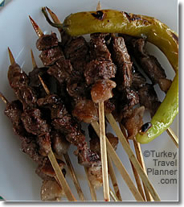
Topcunun Yeri (Well-known with çöp şiş)
No: 3/B Pasaport, Kazim Pasa Cad.
Phone: (0090232) 425 90 47

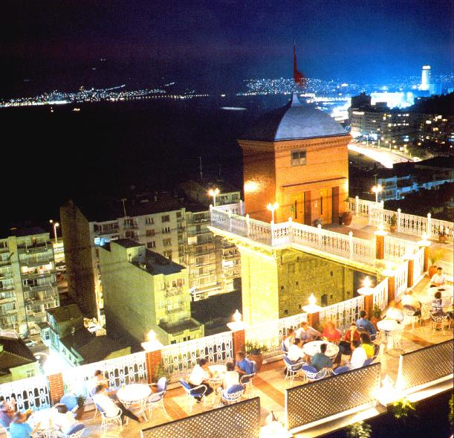
Asansör Restaurant (With Izmir Bay view, historical)
Şehit Nihat Bey Caddesi No: 76/A Mithatpasa
Phone: (0090 232) 261 26 26
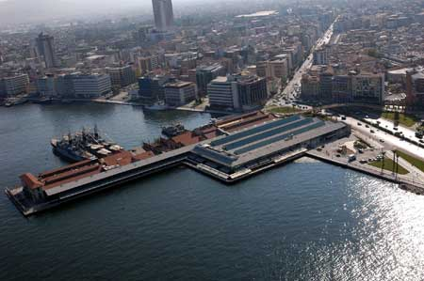

Konak Pier, Mandolin Cafe/Restaurant

Atatürk Caddesi No: 19, 35250 Konak
Phone: (0090232) 483 39 02

Kıbrıs Şehitleri Street: Many Cafeterias and fast Food Places

Deniz Restaurant- Fish Restaurant (located under your hotel, it is some expensive)
Kordon Alsancak Phone: (0090232) 422 06 01
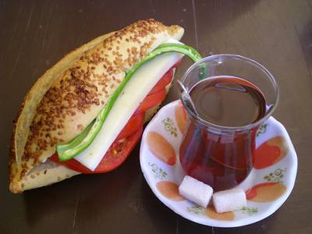
Kumrucu Şevki- Izmir’s Special Kumru (Located
on the other side of the city that you can go by ferry)
Cengiz Topel Cad. No: 9 Bostanlı Tel: (232)330 8600
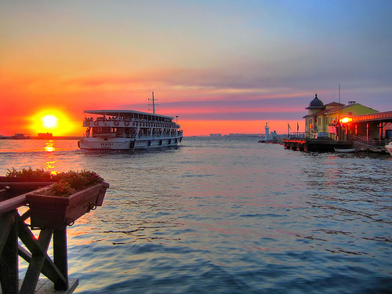

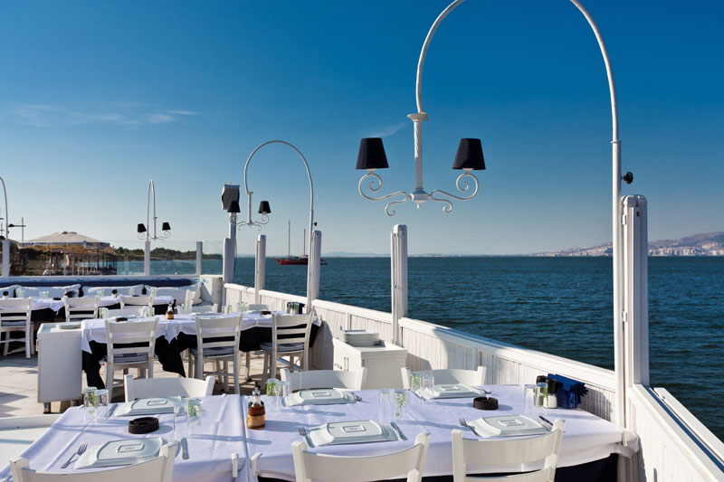
Pasaport Cafeterias to have tea/coffee and watch sunset

Potiri Meyhane-Üçkuyular Marina (Rezervation: +90 232 2590090)

Aegean Cuisine

TRIPS AROUND IZMIR

We recommend you a tour company to arrange you the following trips around. If you have a special request to visit any other places, the company offers many options. Please contact Mrs.Melike Olcaytürk for the details (melike.olcayturk@yasar.edu.tr)

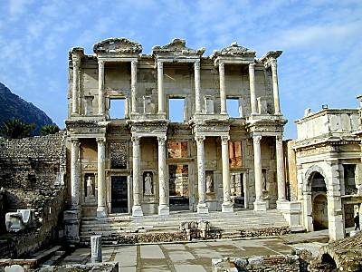
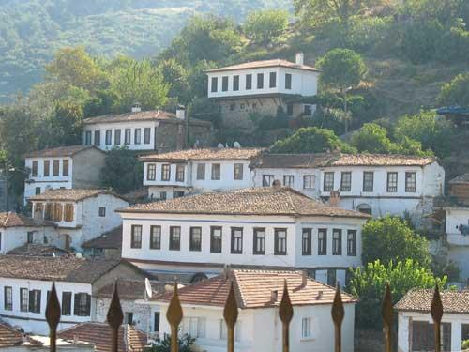
Ephesus and Şirince Village Tour:
(Daily Tour)

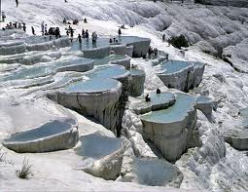

Travertines at Pamukkale/Denizli
It is 4 hours of one way and is recommended as more than 1 day. You can visit museums as well

PRACTICAL INFO

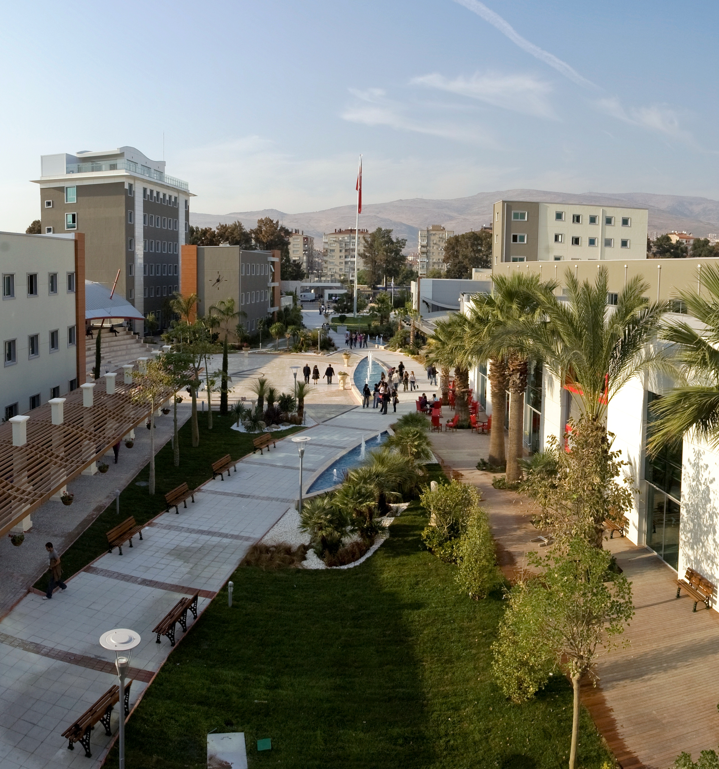
- Yaşar University is just located at BOLGE Stop of Metro.

- If you need an invitation letter, please write to erasmus@yasar.edu.tr together with your teaching/training plan.

- Smoking is not allowed at Yaşar University Campus, even at the open places. There is a special areas for smoking.

- Electrical Voltage: Standard voltage is 220, with 2 pin European standard plugs.

- Promotion Films about Turkey
http://www.kultur.gov.tr/EN/Genel/BelgeGoster.aspx?17A16AE30572D31395FB1C5180B6EBD6A18E78E0AF5B93B4

http://www.goldenhorn-rotary.com/ercu/ERCU_FLASH_eng.html

Izmir Expo 2020: http://www.expoizmir.org.tr/

EMERGENCY NUMBERS
Medical emergency | 112
Health Information | 184
Private ambulance assistance | (0 232)444 0 911
Fire Department | 110
Police | 155

CONTACT
Yaşar University, International Office
Universite Cad. No :37-39 Ağaçlıyol Bornova - İZMİR

E-Mail: erasmus@yasar.edu.tr
Tel: 0090 232 411 50 14
Fax: 0090 232 374 54 74

